**Wealth Management**

**What is 'Wealth Management'?**

Wealth management is a high-level professional service that combines financial and investment advice, accounting and tax services, retirement planning and legal or estate planning for one set fee. Clients work with a single wealth manager who coordinates input from financial experts and can include coordinating advice from the client's own attorney, accountants and insurance agent. Some wealth managers also provide banking services or advice on philanthropic activities.

**Strategies of a Wealth Manager**

The wealth manager starts by developing a plan that will maintain and increase the client's wealth based on that individual's financial situation, goals and comfort level with risk. After the original plan is developed, the manager meets regularly with clients to update goals, review and rebalance the financial portfolio, and investigate whether additional services are needed and with the goal of remaining in the client’s service throughout his lifetime

**The balance act: meeting the needs of all the stakeholders – investors, regulators and organizations (Wealth Manager)**

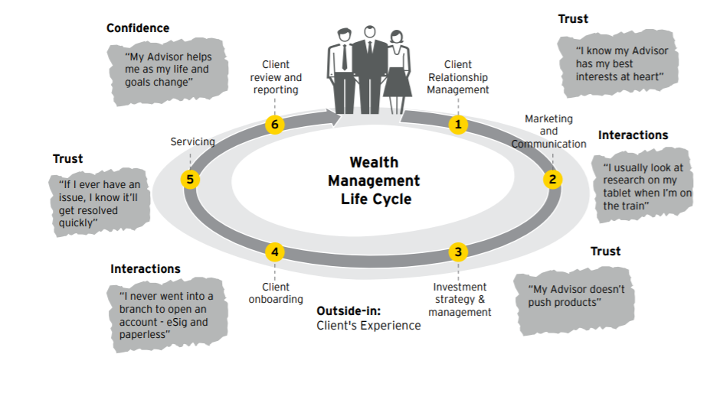

1. **Investors:-**

**1.1 Sense of distrust of advisors after the global financial crisis**

Mis-selling by financial advisors is an important ethical issue affecting market integrity across the globe. Historically, wealth managers and advisors relied heavily on their reputation to gain the trust of clients. Strong reputations are not easily won; they must be earned over time through investment results and exceptional client service. While firm reputation is a crucial factor for clients, transparency in fees and portfolio performance has ranked above other factors as a key trust driver globally.

**1.2 Sophisticated clients are more focused on capital preservation and value for fees**

Clients have become more focused on capital preservation and value for fees, with 73% of high-networth individuals (HNWIs) rating clear understanding of risk tolerance and fee transparency as “high importance”.1 Notably, HNWIs rate correct assessment of risk tolerance and transparency in fees more important than even strong investment performance

**Wealth Management Use Cases in Blockchain:-**

1. client onboarding process
2. streamline management of model portfolios
3. speed the clearing and settlement of trades
4. ease compliance burdens associated with anti-money laundering (AML) and know your customer

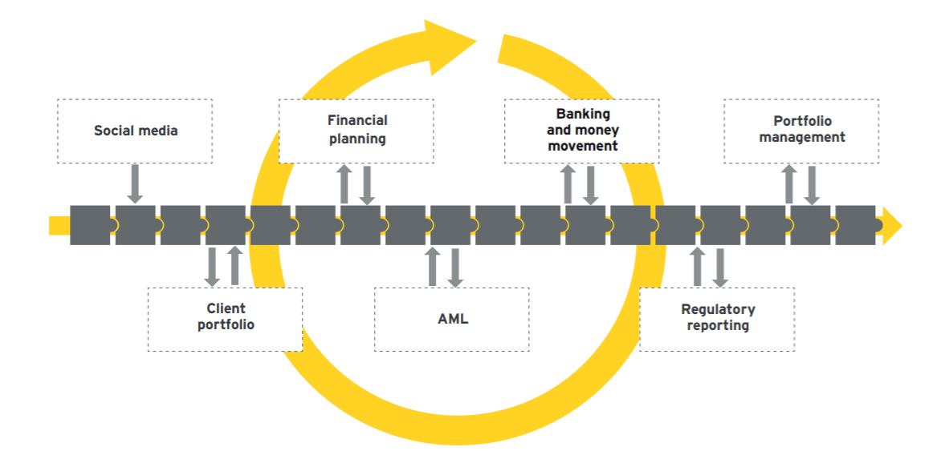

1. **Model management and trade order generation**

The proliferation of open architecture investment offerings and the availability of third-party investment models in separately managed accounts have presented a number of operational challenges for wealth managers. Distributed ledger technology would allow portfolio managers to instantly communicate portfolio changes to all clients “subscribed” to the model, as well as enable real-time views of individual account performance, drift outside of tolerances and cash flows. Also, smart contracts would allow for the management of fees paid by the sponsors — essentially taking a payment every time the model is used or downloaded.

**Questions:-**

1. How portfolio management works? Can we provide investment/retirement planning suggestions to customer on blockchain based solution?

(Plan to combine all wealth (investment/retirement/estate etc planning) in one blockchain based solution)

1. Investment Counsellor/Advisor is employee (part) of RBC?
2. Incorporate regulatory changes in blockchain using smart contracts.